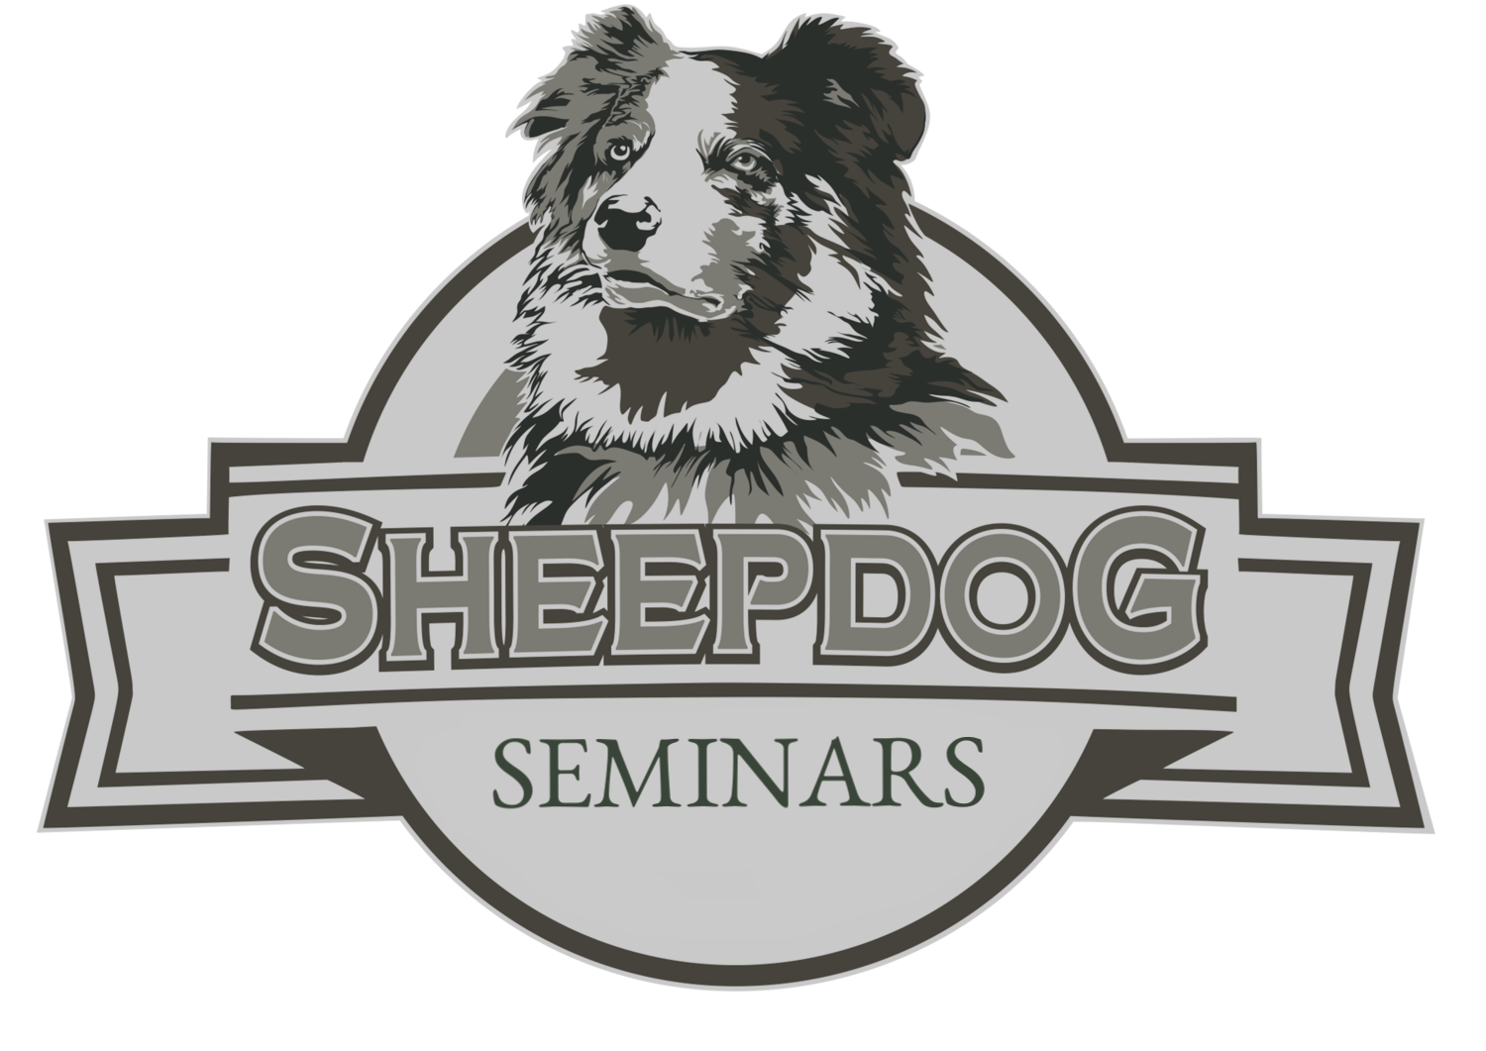

**Owner sheepdog seminars**

was in attendance at the Flat Rock, North Carolina

Sheepdog Seminar

July 19 - 20, 2019

CERTIFICATE

Of attendance

Jimmy Meeks

**Total Hours 10**