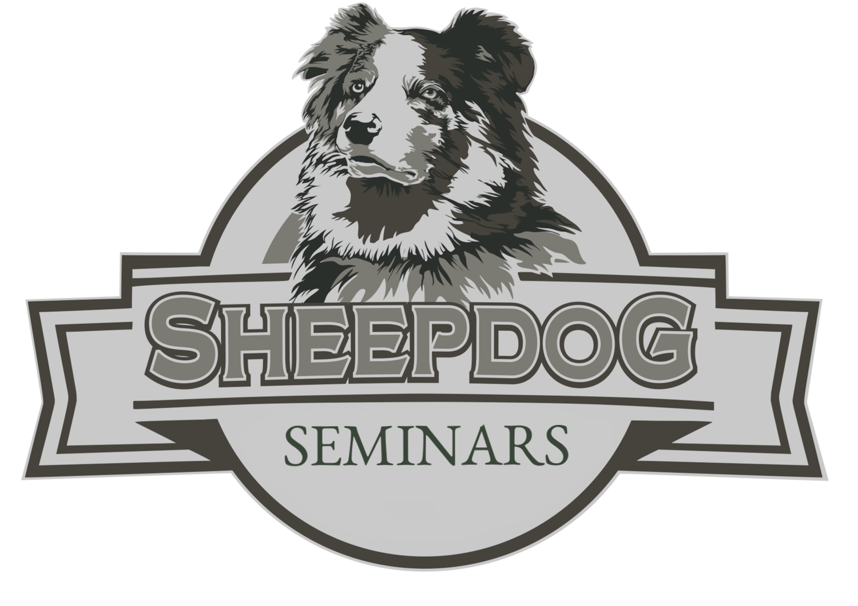

was in attendance at the Camarillo, California

Sheepdog Seminar for Churches

September 16, 2019

CERTIFICATE

Of attendance

**Total Hours 8**

Jimmy Meeks

Owner, Sheepdog Seminars