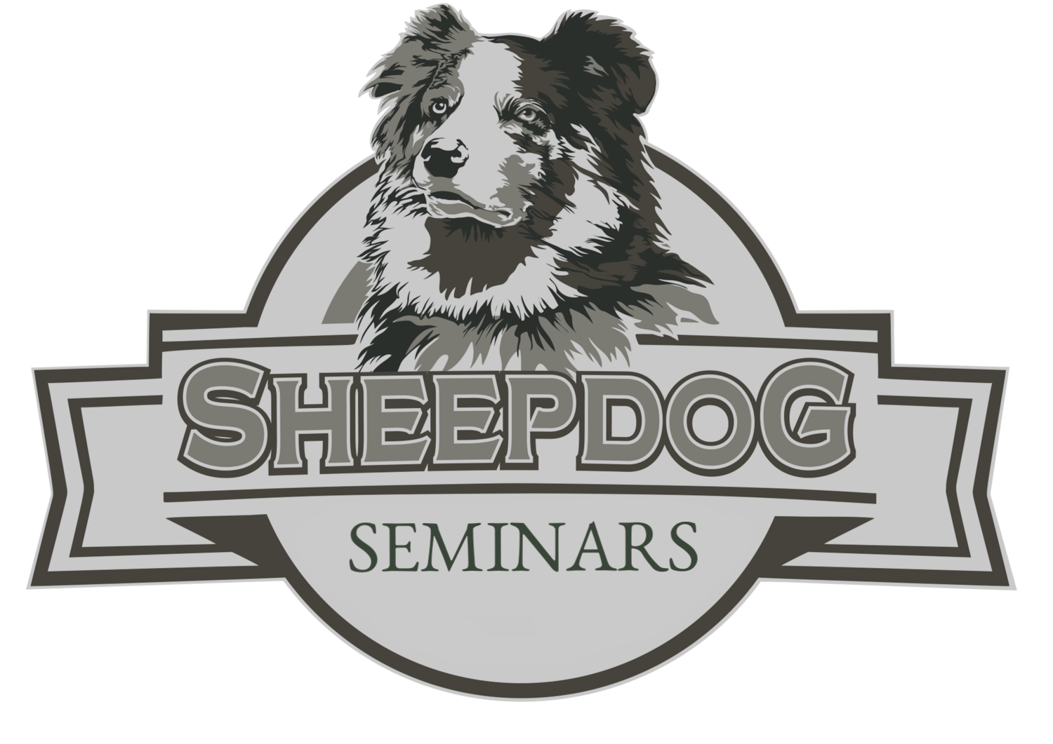

was in attendance at the Bothell, Washington

Sheepdog Seminar

MARCH 29-30, 2019

CERTIFICATE

Of attendance

**Owner sheepdog seminars**

s

Jimmy Meeks

**Total Hours 10**